**Music supplement for the Lutezine to Lute News 134 (April 2020): Melchior Neusidler part 8 and collected settings of Ich weiß ein stolze Müllerin, Conde claros, Val cerca and Branle de la gavotte plus more sources of music by Jacob Reis**

**Deutscher Dantz - Hudson 6: Ich weiss mir ein stolze/ schöne /hü**[**b]sche Müllerin - Ludwig Senfl**

The deutsch dantz series continues with number 6 on Richard Hudson's list,[1] the only one identified as a setting of a known lied, Ludwig Senfl's 4-voice *Ich weiss ein stolze Müllerin* (I know a beautiful/pretty miller).[2] Seven lute versions (**H6a-g**) are dantz settings of it all but two with a triple time nachdantz (after dantz) and all in German tablature sources - although H6a & b are nearly identical versions in two of Hans Newsidler's prints and H6c & d are identical so the scribe of the manuscript presumably copied it from Heckel's print. The dantz settings, some needing reconstruction, usually retain the two strains of four and ten bars of the lied with the first repeated but the triple time nachdantz vary and extend the B strain. **H6h-i** are simple two and three part setting of the original lied.

**H6a.** Newsidler 1540, sigs. B1v-B1v *Wayss mir ein hü*s*che Mülnerin*

*- Hie folgt der hupff auff* - AA4B10-AA8B26 p. 2

**H6b.** Newsidler *Erst* 1544, sigs. C2v-C3r *Ich wais mir ain stotlze*

*Mülnerin 13 - Hupff auff* - AA4B10-AA8B25 3

= Newsidler 1547, sigs. B4v-C1r *Ich wais mir ain stotlze Mülnerin*

*- Hupff auff*

**H6c.** NL-At 208.A.27, ff. 69v-70r *Ich Weis Ein schone Mullerin*

*etc. LXXVII - SALtarello* - AA4B10-AA8B26 4

**H6d.** Heckel 1556/1562, pp. 129-131 *Wider ein schöner Tantz / Ich weysz*

*mir ein schöne Müllerin - Proportz auff die Müllerin* - AA4B10-AA8B26 5

**H6e.** Jobin 1573, sigs. H1v-H2r *Dantz - Nach dantz* - AA4B14-AA8B28 6-7

**H6f.** CH-Bu F.IX.70, p. 254 *XLVI Ich weisz mir ein stoltze müllerin* - A8B17 7

**H6g.** A-Wn 18688 (Craus), f. 34r/89r *Die Milnerin* 8

**H6h.** D-Mbs 1512, f. 12r *Ich waiß ein stoltze Mullerin hd* 9

**H6i.** D-Mbs 1512, f. 29r *Ich wais ein stoltze Mullerin hd* 8

**Melchior Neusidler part 8**

The next group of three pieces by Melchior Neusidler are in different tonalities, the fantasia, his most popular judging by the number of surviving sources, in D major, the vocal intabulation, Arcadelt's chanson Souspirs ardens, in F minor, and the Dorisanen Dantz, unique to Melchior's 1574 print, in G major. The fantasia is ascribed to Melchior in four sources but to Fabritio Dentice by Philip Hainhofer, although it is likely to be an error as Melchior claims to have composed the fantasias in his prints. The intabulation of Arcadelt's chanson *Souspirs ardans, parcelles se mon ame* in Melchior's 1574 print is highly embellished. When comparing all the other sources for lute, I recognised that two less elaborate settings in D-Mbs 266 are concordant versions of his setting and so one of them is included here, from a section of the composite manuscript thought to be copied by Melchior himself. Anonymous settings a minor third lower are also known and one is included here for comparison (MN8app). The dantz is presumably Melchior's arrangement of an existing dantz, although no other music for it is known.

**MN8a.** D-Mbs 266, ff. 93v-94r *Fantasia MN* 10-11

Neusidler 1574, sigs. N2v-N3v *44 Fantasia. MN*

B-Br II.275 (Cavalcanti), ff. 97v-98r untitled

CH-Bu F.IX.70 (Würstisen)), pp. 53-54 *XV Fantasia MN*

D-W Guelf 18.7, ff. 203v-204v *Phantasia Fabritius Dentici*

D-LEm II.6.15, pp. 60-61 *Fantasia 12*

PL-Kj 40598, ff. 31v-32r *Fantasia MN*

A-Wn S.M.8967, ff. 4r-6r *Fantasia* - tone lower

**MN8b.** D-Mbs 266, ff. 7v-8r *Suos spirs ardans* 12-13

D-Mbs 266, f. 104v *Sou sprardans*

Neusidler I 1566, pp. 14-15 *Suspirs ardans*

= Phalèse & Bellère 1571, f. 42v *Souspirs ardans* = Drusina/Neusidler 1573, sigs. C3v-C4r *Suspir ardans*

model:[3] *Souspirs ardans, parcelles se mon ame* Archadelt RISM 15598

**MN8app.** S-Uu 87, f. 34r *Souspirs ardans l'Archadelt* 14-15

texted and melody indicated with dots (red notes here)

cognates: S-Uu 412, ff. 29v-30r *Souspres ardens*; Le Roy *Sixiesme Livre de Luth* 1559, ff. 3r-4v *Souspirs ardans* [index: *Arcadet*]; Phalèse 1568, f. 43v *Souspirs ardans* [header: *Arcadet*]

See E6. S-Uu 412, f. 9v *Souspirs ardens* *par dinton* - in C minor *Lute News*

**MN8c.** Neusidler *Teutsche Lautenbuch* 1574, sigs. L2v-L3r

*Der Dorisanen Dantz 38 - hupffauff* 16-17

**Music for Queen Mary continued**

Four lute solos dedicated to Mary Stuart, and maybe Mary of Guise or Mary Tudor, were edited for the supplement to *Lute News* 134 and additional sources of three of them are here. The first was a galliard for the Queen of Scots (Q1a) and a cognate related to it is included here as **Q1b** although the meaning of the title *galliard caled phillida* is obscure. Both of them quote the tune of the Spanish romance Conde claros at the beginning and all the variations on this tune that I know are edited below. The second was a *Gailliarda la Royne d'escosse*, referring to Mary Stuart, although it is in fact a setting of a popular tune known as Val cerca in Italy, and all the versions of it will be found below. The third is *Queen Maries Dump* and one source was in *Lute News* 134 and concordant or cognate sources, four for lute and one for renaissance guitar, are here (**Q3b-f**). The fourth was another *Queene Maries Dumpe* (Q4), but no other sources for plucked instruments are known.

Q1a. IRL-Dm Z3.2.13 (Marsh), p. 61 *Gally:* *queen Scottes* *Lute News*

**Q1b.** IRL-Dtc 408/II, pp. 108-109 *a galliard caled phillida* 18-19

Q2. Phalèse 1568, f. 82r *Gailliarda la Royne d'escosse* *Lute News*

Q3a. GB-Cu Add.2764(2), ff. 1r-2r *Queene Maries Dumpe* *Lute News*

**Q3b.** IRL-Dtc 410/I (Dallis), pp. 192-193 untitled 54-55

**Q3c.** US-Ws V.b.280 (Folger), f. 1r *queene Maries dumpe* 55

**Q3d.** IRL-Dtc 408/I (Ballet), pp. 4-5 *Queene Maries Dump* 56-57

**Q3e.** cf. GB-Lbl Roy.App.58, f. 54v untitled 57

**Q3f.** US-NH osborn 13 (Braye), f. 42v-43r *pavana* - guitar 58

**Conde claros**

A set of variations on Conde claros was in the supplement to *Lute News* 135 (C1) and a galliard for the Queen of Scots (Q1) that quotes the Conde claros tune. The remaining settings of Conde claros, three for lute (C2-C4) plus a duet for lutes a fourth apart (C17), six for vihuela (C8, C10-12 & C15-16),[4] five for guitar/gittern (C5-7, C9 & C13)[5] and one for cittern (C14),[6] are included here, grouped according to the notational difference as I described in *Lute News,* with C2-7 in the form of variations of four bars in triple time found in the English sources and C8-17 in the form of six bars in duple time found in the vihuela sources (the title pages of the prints illustrated here).[7] The sources from France and The Netherlands include examples of both forms and in his *Hortus Musarum* of 1552 Phalèse created a lute duet (C17) by combining solo variations copied from two solo sets in different keys in the vihuela print of Valderrabano (C15-16).[8] Phalèse reproduced the variations as three bars of six minims instead of Valderrabano's six bars of two minims and introduced a few minor differences. The three English sources (C1-3) are nearly identical except for minor differences in figuration, C2 lacks division 19 (bars 73-76 of C1) and C2 & C3 end with a 6-bar coda in duple time (barred editorially). All three are for a lute with the sixth course tuned down to F, but Mathew Holmes the copyist of C1 used an F on the seventh course in bar 13 probably in error as he uses F on sixth course from then on, so I took the liberty of adapting it for a seven course lute throughout whereas C2 & C3 here retain the scordatura tuning of the sixth course in F. The seventeen settings here are all different (except the concordant English sources C1-3) 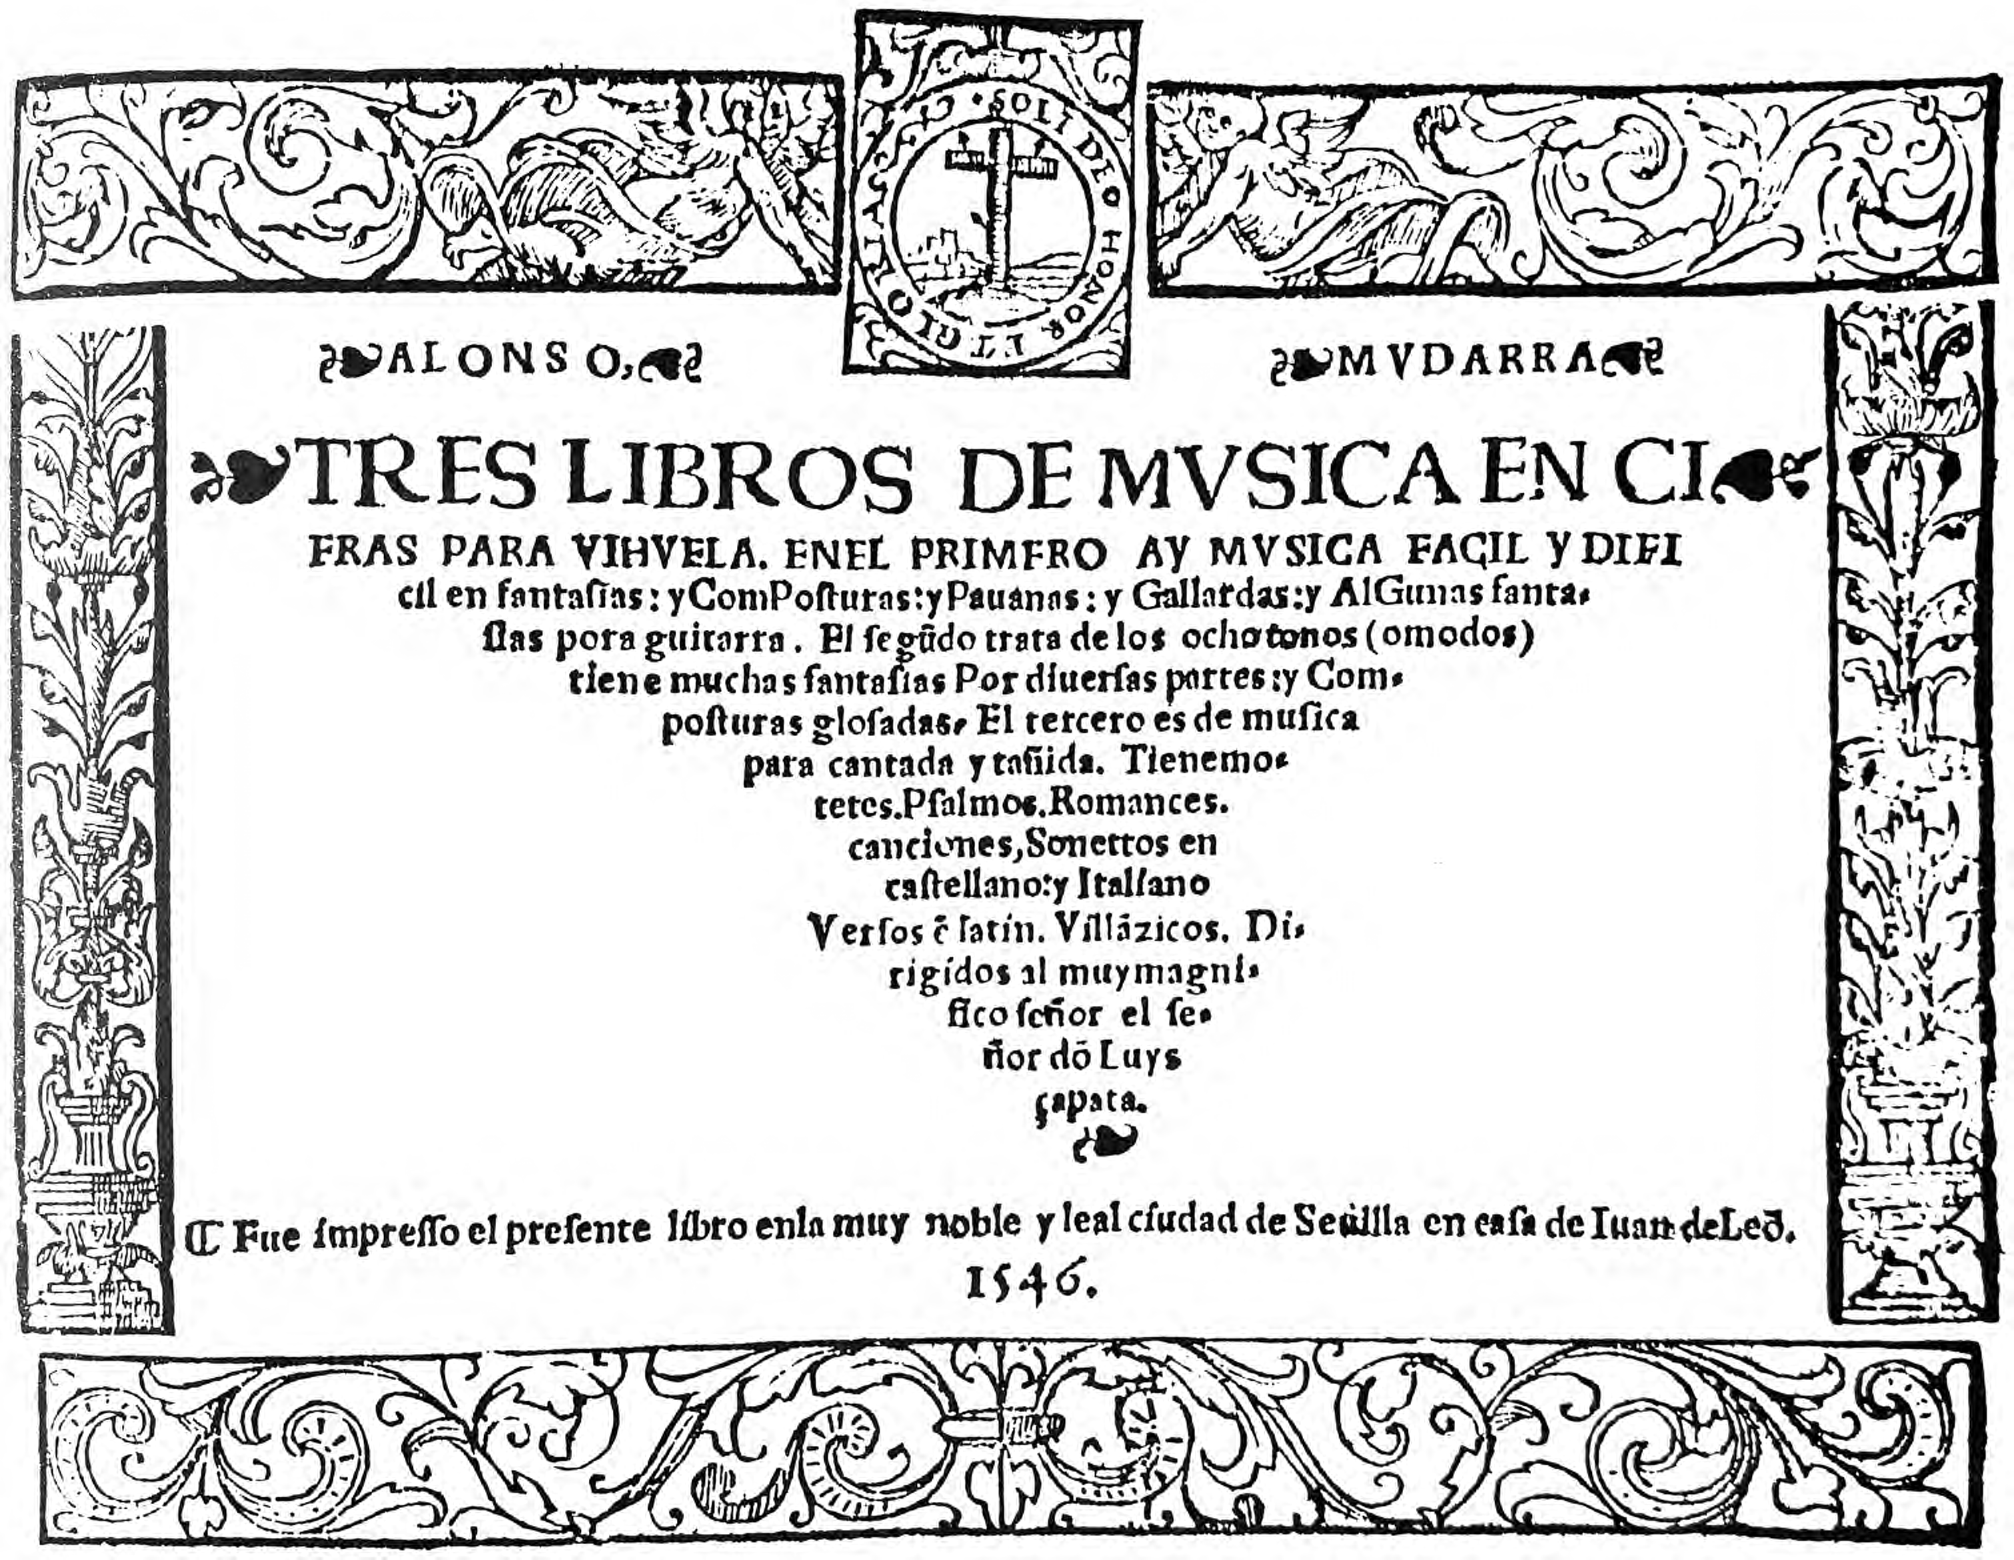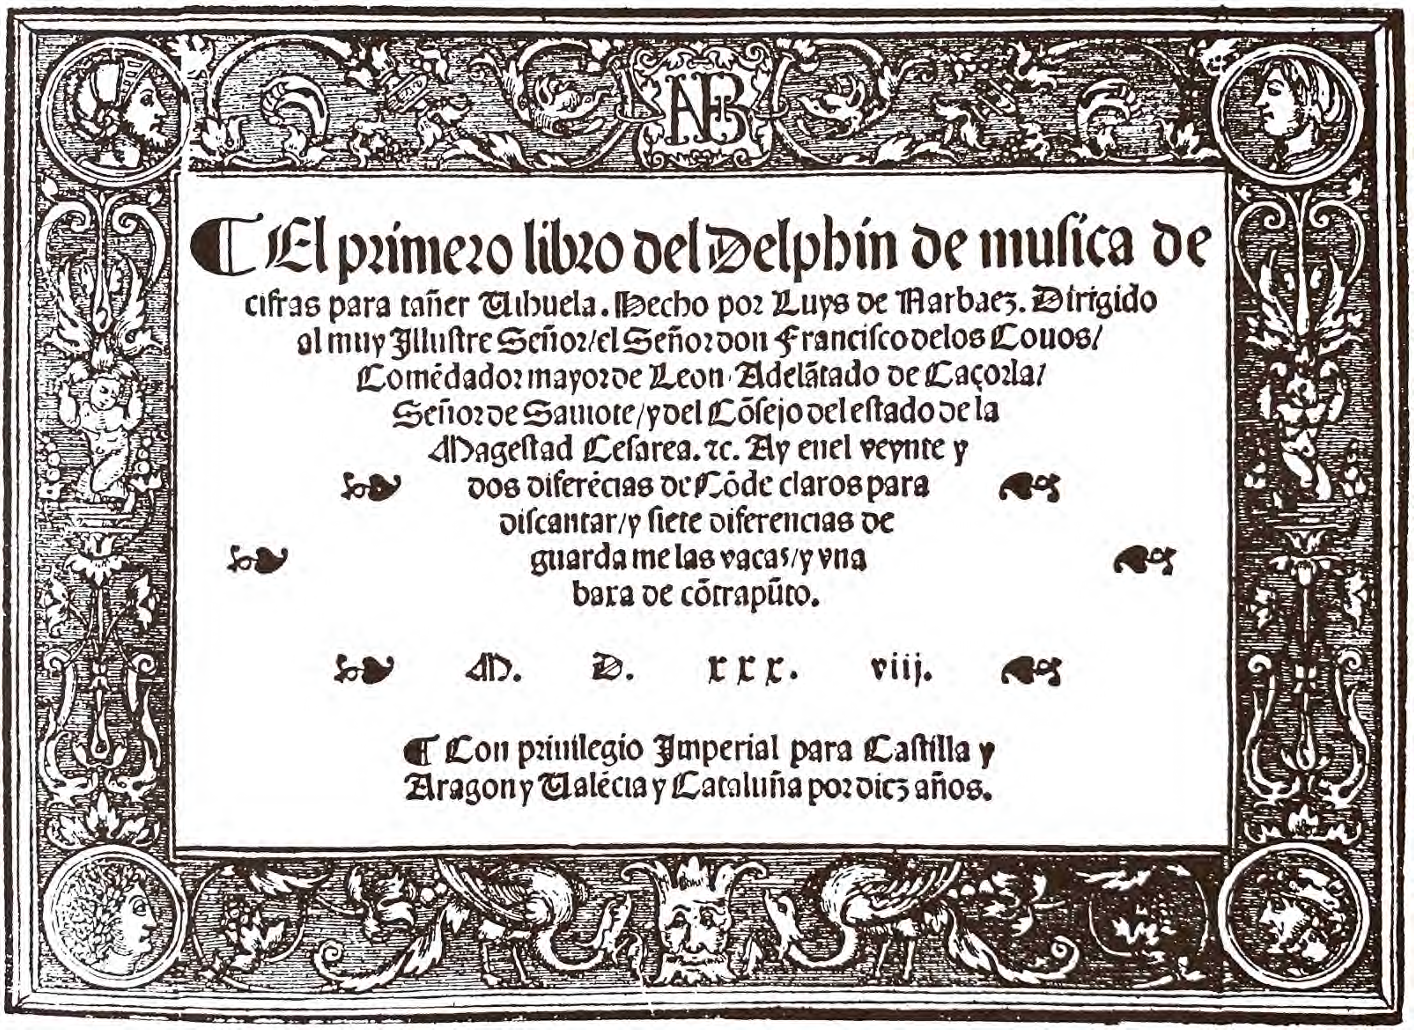and include between two and seventy four variations (445 bars in V16!), but even the longer sets maintain interest through inventive figuration and rhythmic variety.

C1. GB-Cu Dd.5.78.3, ff. 73v-74r untitled *Lute News*

**C2.** GB-NO Mi LM 16 (Willoughby), ff. 38-39v *Qande claro -*

*Quande claro folio 22* (*owt of Greenes booke*?) pp. 20-21

**C3.** IRL-Dm Z3.2.13, pp. 232-233 untitled 22-23

**C4.** I-CFVd (Castelfranco Venuto), f. 55v *Conde claros* 24

**C5.** Morlaye II 1553, f. 29r *Conteclare* - guitar 25

**C6.** US-NHub osborn 13, ff. 45v-46r *quando claro* - gittern 26-27

**C7.** Morlaye I 1552, ff. 24v-25v *Conte clare* - guitar 27

**C8.** E-SIM Legato 394,[9] f. 1v *Contrapunto sobre el Conde Claros* 19

**C9.** Morlaye II 1553 4, ff. 29v-30r *Conte clare* - guitar 25

**C10.** Mudarra I 1546, ff. 15v-16v *Conde Claros* 28-29

**C11.** Pisador 1552, ff. 1r-2v *Yesto primero es vn Conde claros con ciertas differencias paralos principiantes y para los que mas saben* 29-32

**C12.** Narvaez 1538, ff. 82r-86r *Conde claros del sesto tono* 33-35

variations numbered & 15: *Lo*[n?]*tra ehaziendo la guitara*,

20: *De proporcion seys numismas al compas*

**C13.** Morlaye IV 1552, ff. 18v-19r *Contreclare a corde aualée* - guitar 36

**C14i/ii.** Morlaye IV 1552, f. 27v *Contreclare* (*Ce qui sensuit, est pour iouer*

*sus la Cistre*) - diatonic cittern & transcribed for chromatic cittern 36

**C15.** Valderrabano 1547, ff. 97v-99v *las diferencias sobre el tenor*

*del co*[n]*de claros* 37-41

**C16.** Valderrabano 1547, ff. 99v-102v *Conde claros*

[*otras diferentes duiferentias*] 42-49

**C17i.** Phalèse 1552, p. 102 *Conde claros Superius* - duet lute I 50-51

= C16 bars 1-139 (first 23 variations of 74 total in Valderrabano)

**C17ii.** Phalèse 1552, p. 103 *Conde claros Tenor* - duet 52-53

= C15 bars 1-127 + 1-6 (first 21 variations of 49 total in Valderrabano)

cf. Henestrosa 1557, f. 65v *Cinco differencias sobre conde Claros. glosa* - 5 variations for keyboard

Additional: Valderrabano 1547, ff. 48v-50r *conde Claros Figuela mayor - con otra boz deco[n]tra punto Figuela menor* - duet for vihuelas a 3rd apart?

**Val cerca**

This dance of three strains of 8, 8 and 4 bars, the latter modulating to the relative minor was popular in a number of countries each with different titles, *Wij sal mij troetelen* in The Netherlands, *Gailliarde de la Royne d'Ecosse* in France, *Woll auff mein junges hertz* in Germany and *Val cerca* probably after an Italian street song, as well as *Milanoise* and *Piemontoise*, dance types from Milan and Piedmont near Turin. Two settings (Q2 & V1) were in *Lute News* 134 and all the others known to me are here. I wonder how many readers own a renaissance lute, renaissance guitar and diatonic cittern to play all the versions of these one after the other - and maybe a vihuela too to play the Conde claros variations above! Versions for lute are mainly in one of two different tonalities, and those in each are quite similar, but close inspection reveals a diversity of figuration in particular in handling the semibreve sequence in the second strain retained unadorned only in the Italian source V4. **V1-24** (V1 is in *Lute News*) are in B flat major with the C strain in the relative minor, G and are all quite similar although no two are the same except for two in the Scmal lute book (V13-14), and the cognate setting in Italian tablature in Borrono's print transcribed almost identically into the prints of Wyssenbach, in German tablature, and Phalèse, in French tablature (V19-21). Occasional bars or passages are shared exactly by different settings presumably representing circulation of a pool of inter-related exemplars. **V25-29** and Q2 in *Lute News* are six settings a major second higher in C major/A minor, none quite the same. **V30-31** are a pair from the Donaueschingen lute book, the first in E flat/C minor and the second in G major/E minor, lacking the tune and sounding like a second part to a duet or a consort part.[10] **V32-36** are settings for diatonic cittern in french tuning and are concordant with each other apart from subtle differences in figuration, except V32 is a major second higher with a different melodic outline and in two not three strains despite using one of the same titles. One setting is also known for renaissance guitar (**V37**). **V38 and V39** are two lute quartets from the Thysius lute book, the first with the tune in the contratenor or second lute part and the second with the title *Gallarde de Royne d'escosse* but quite a remote cognate for the music here if indeed related at all as the title would suggest.[11] Settings for keyboard and instrumental ensemble are also known.

Some settings have one or more bars missing (V13, 14, 22, 23 & 29) and have been reconstructed and editorial changes in these and all the music in this supplement are highlighted in red.

V1. F-LYm 6244, ff. 12v-13r *Val cerca* *Lute News*

**V2.** D-Z 115.3 (Arpin), f. 33r [p. 59] untitled 59

**V3.** CH-Bu F-IX.70, p. 301 *XVI. Galliarda* 59

**V4.** I-CFVd, f. 108r *Val cerca Gagliarda - Questa gagliarda e a u Liuto Solo*

*- Joauanni Pacalono Padoano mana propria 1565 Patauij die xv mensis May:* 60

**V5.** S-Su instr.mus.hs.412, f. 24v *C'est toy* 61

**V6**. S-Su instr.mus.hs.412, ff. 17v-18r *Milanoise* 62

**V7.** Waissel 1573, sig. L4v *41 Val cerca. Gagliarda* 63

= NL-At 208.A.27, f. 59v *Val Cerca gagliarda M: W: XLV*

**V8.** Phalèse 1563, f. 61r *Galliarde* 64

**V9.** PL-Kj W 510, f. 34v *Galiardt* 65

**V10**. Waissel 1592, sig. F2v *6. Gailliarda* 66

**V11.** Phalèse 1568, f. 85v *Gaill VVij sal mij troetelen* 67

**V12a.** Le Roy 1568, ff. 36v-37r *The thirde Milanoise* 68

**V12b.** Le Roy 1568, ff. 36v-37r *The thirde Milanoise* 69

- annotated by hand and initialed *AB*

**V13.** CZ-Pu XXIII.F.174 (Scmal), f. 47r ii *Gagliarda* 70

**V14.** CZ-Pu XXIII.F.174, f. 48r *Gagliarda* 71

**V15.** NL-Lu 1666 (Thysius), f. 24r-24v untitled 72

**V16.** DK-Kk Thott 841,4o, f. 51av *93. Wer* *soll mich Trautelen* 73

**V17.** E-SIM Legato 394 folio 130, leaf B, f. 1r *la moreda* 73

**V18.** DK-Kk Thott 841,4o, f. 87v *164 Woll auff mein junges hertz*

*Galliarda* - voice and lute with text[12] 74

**V19.** Phalèse IV 1546, sigs. gg2v-gg3r *Galiarda IIII* 75

= Phalèse & Bellère IV 1573, sigs. gg2v-gg3r *Galiarda IIII*

**V20.** Milano & Borrono II 1546, ff. 6v-7r *Saltarello terza*

*detto la Barbarino* 76

**V21.** Wyssenbach 1550, ff. 10r-10v *Der dritt Spri*[n]*g*[er]*dantz*

*genannt La Barbarina* 77

**V22.** DK-Kk Thott 841,4o, f. 108v *Galliarda Wolauff mein junges hertz* 78

**V23.** D-B 40141 (nauclerus), f. 93v *Woll auff Mein Junges Hertz* 78

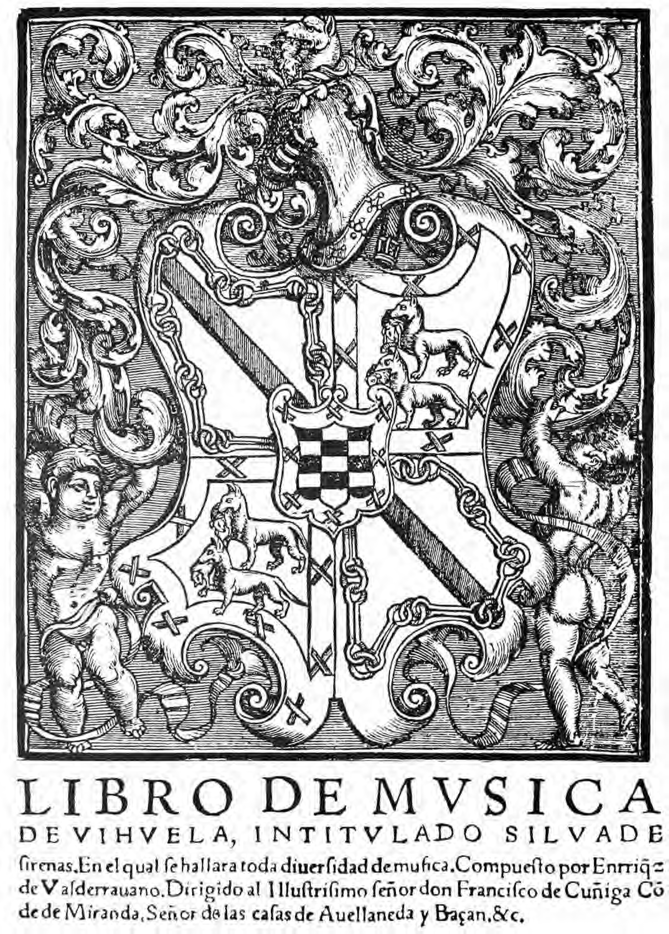

**V24.** Morlaye II 1558, f. 22r *Gaillarde piemo*[n]*toise* 79

**V25.** CH-Bu F.IX.70, p. 309 *XXXI. Galliarde* 79

**V26.** PL-Kj 40032, p. 314 *Gagliarda Milanesa* 80

**V27.** D-DEl BB 12150, f. f. 68r *Gagliard* 81

**V28.** Barbetta 1585, pp. 44-45 *Saltarello 4. detto O la val cerca* 82

**V29.** Jobin 1573, sigs. D4r-D4v *Gailliarde* 83

**V30.** D-Sl G.I.4/I, f. 9v *Val cercha* 84

**V31.** D-Sl G.I.4/I, f. 9v *Item* 85

**V32.** Vreedman 1568, f. 50v *Gaill VVij sal mij troetelen* - diat. cittern 72

**V33.** Phalèse & Bellère 1582, f. 63v *Gailliarde de la Royne d'Ecosse*

- diatonic cittern 86

**V34.** Vreedman 1569, f. 44v *Gaiarda la royne d'Escosse* - diat. cittern 86

**V35.** Phalèse & Bellère 1570, f. 48r *Qvatrieme milanoise -* diat. cittern 87

**V36.** Viaera 1564, f. 33r *Gaiarda de la Royne de Eschosse* - diat. cittern 87

**V37.** Phalèse & Bellère 1570, f. 67r *Troisieme gaillarde milanoise* - guitar 74

**V38i.** NL-Lu 1666, f. 25r *Bassus. Wie sal mijn troetelen* - lute I in A 88

**V38ii.** NL-Lu 1666, f. 25v ii *Contratenor* - lute II in G 88

**V38iii.** NL-Lu 1666, f. 24v *Wie sal mein troetelen. Sups* - lute III in E 89

**V38iv.** NL-Lu 1666, f. 25v i *Wie sal mein troetelen. Tenor* - lute IV in D 89

**V39i.** NL-Lu 1666, f. 13v ii *Bassus* - lute I in A 90

**V39ii.** NL-Lu 1666, f. 14r i *Contraten*[or] - lute II in G 90

**V39iii.** NL-Lu 1666, f. 13v i *Gallarde de Royne d'escosse*

*Sup*[eriu]*s* - lute III in E 91

**V39iv.** NL-Lu 1666, f. 14r ii *Tenor* - lute IV in D 91

Keyboard: D-B 40034 (Löffelholz), f. 18r *Galliarda 21*; Ammerbach *Orgel oder Instrument Tabulaturbuch* 1583, p. 177 *Ein ander Galliarth*. Instr. ens.: dTertre *Septieme Livre de Danceries* 1557, f. 1v *Gaillarde premiere -* à 4; Estrée *Quart Livre de Danceries* 1564, f. 14r *Galliarde a 5*.

**Jacob Reis - miscellaneous continued**

Of the seven items by Jacob Reis in *Lute News* 134, only one is known from more than one source, the gagliarda J2, so here are the other four sources, the first two closely related to each other as are the second two. Although it seems likely Jacob composed the original gagliarda, there is surprising variability in the figuration between the sources suggesting that it evolved over time in Jacobs hands or was arranged by others.

J2a. I-COc 1.1.20, ff. 25v-27r *Gagliarda* - JacobP p. 186 *Lute News*

**J2b.** Besard 1617, sig. L2v i *37 Gagliarda del Signor Jacob gia chiamata*

*il Polloneze*[13] - JacobP p. 112 92

= CH-Bfenyves Mus. Ms., f. 40v *gia chiamata il Poloneze*

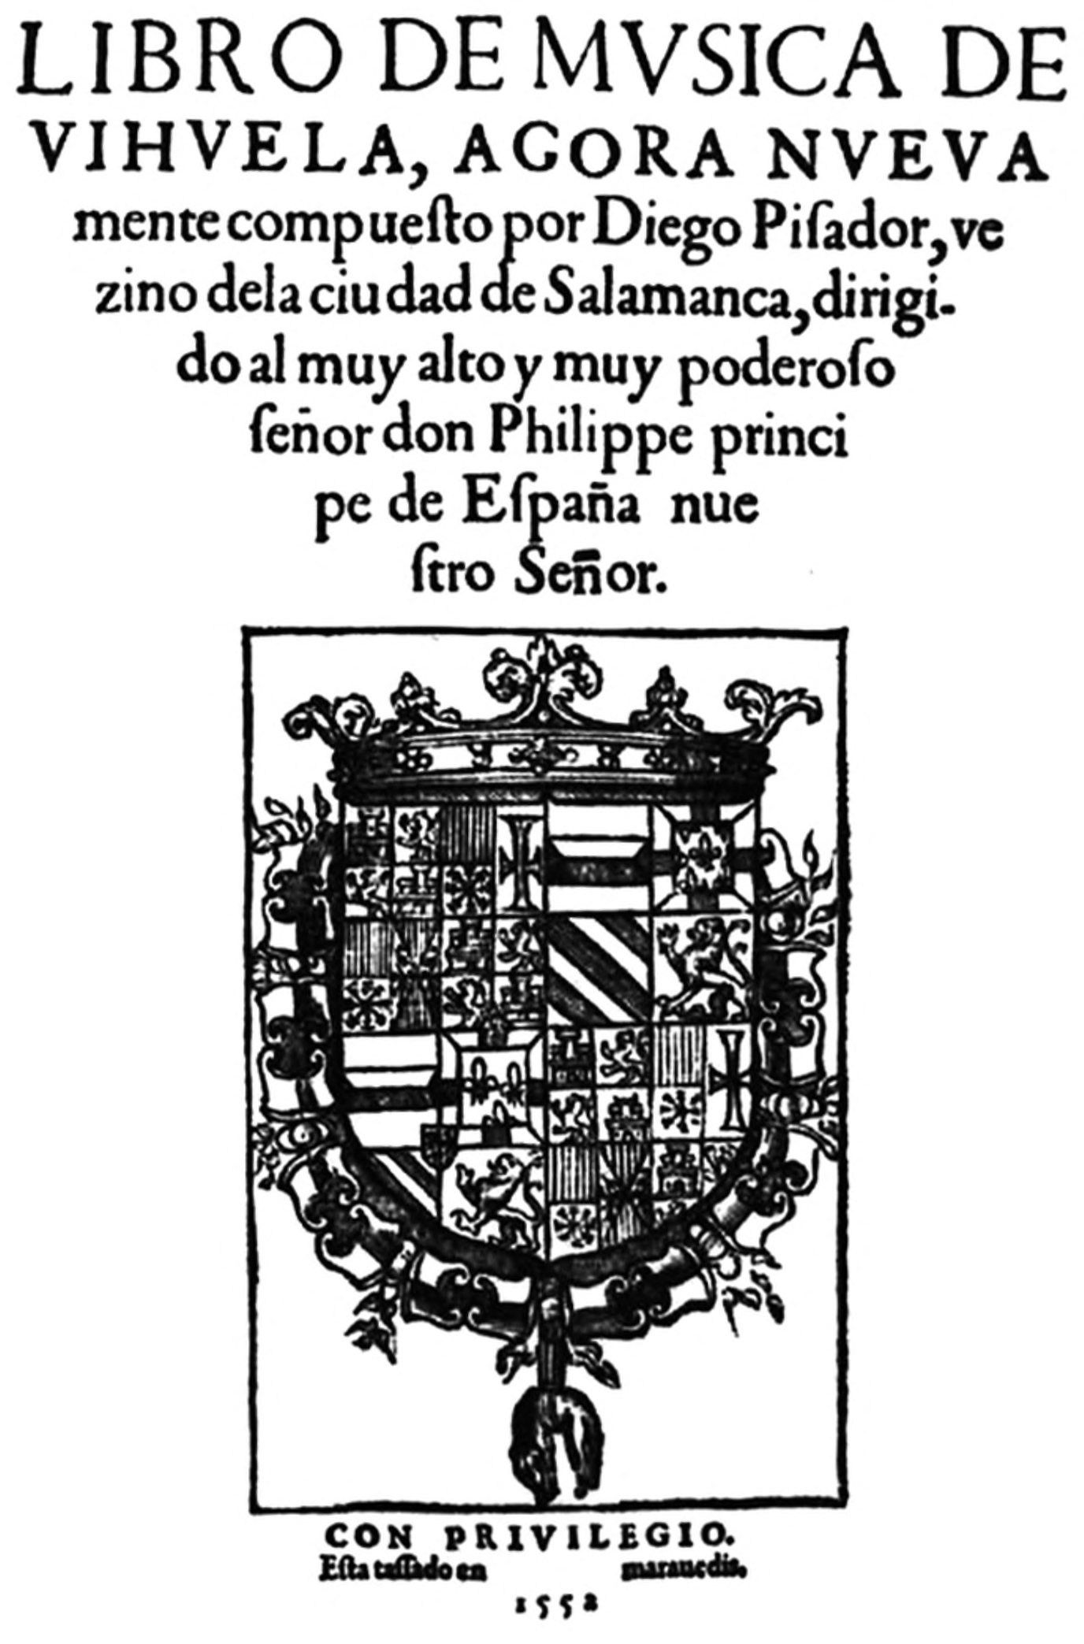

**J2c.** GB-HAdolmetsch II.B.1, ff. 71v-73r *Galliarde* 93

**J2d.** I-COc 1.1.20 (Raimondo), ff. 21r-22r *Gagliarda* 94-95

**J2e.** Hove *Florida* 1601, f. 98v *Galiarda* - HoveB[14] no 370 95-96

**Gavotte**

A fantasia and a branle de la gavotte ascribed to Cidrac Rael were edited for *Lute News* 134. A transposed version of the fantasia is ascribed to Diomedes and was edited as fantasia 14 in *Lute News* 97 (March 2011) in the Diomedes Cato series.

Anonymous cognate settings of the branle de la gavotte are included here, two in cordes avalée tuning (fefhf) in the original but transcribed for renaissance lute here. Three settings are in Besard's *Thesaurus Harmonicus* of 1603, the one in cordes avallée tuning copied nearly exactly into the Rettenwert lute book. Gavottes are rare in renaissance sources but examples abound in the seventeenth century for lute in transitional and baroque tunings. Antoine Francisque's Le *Tresor D'Orphée* of 1600 includes two suites of branles ending with a gavotte.[15] Cognates are also found in lute manuscripts of German and Italian provenance.

R2a/G1. Besard 1603, f. 146r *Branle de la gauotte alterius toni*

*à Cidrac Rael Biturcenti* [of Bourges] *composit* *Lute News*

**G2.** Besard 1603, f. 145v *Branle de la gavotte* p. 1

**G3.** PL-Kj Mus.40143, ff. 34r-34v *Gavotte Ao 1601 3 Martij* 97

**G4.** Besard 1603, ff. 148r-148v *Branle de la gavotte a. C*[orde]*.*

*A*[ualee]. - *Ripressa ad superiorem choream* (fefhf) 98-99

**G5.** CZ-Pnm IV.G.18, ff. 157v-158r *Branle de la Gavotte* (fefhf) 100-101

**G6.** I-Fn Magl.XIX.106, ff. 9v-10r *Gavotta* 101

**G7.** Francisque 1600, ff. 21r-21v *GVauotte* 102-103

**G8.** D-LEm II.5.32b, f. 9v *gauotte* 103

**Appendices**

The only known lute setting of a brande d'escosse together with a cittern setting were in *Lute News* 134 and a setting for guitar and another for cittern are here. The cittern setting App 1d is titled *Passe pied* but is a remote cognate for Le Roy 1564, f. 23r also titled *Passepied* and for diatonic cittern (App 1b in *Lute News*) which has the alternative title *Branle d'Escosse* in the index.

App 1a. S-Uu instr.mus.412, f. 30v *Premier branle d`escosse* *Lute News*

App 1bi. Le Roy 1564, f. 23r *Passepied* - diatonic cittern *Lute News*

[index: *Branle d'Escosse*]

**App 1c.** Phalèse 1570, f. 76v *Branle d`ecosse* - guitar 17

**App 1d.** Phalèse & Bellère 1570, f. 50v *Passe pied* - diatonic cittern 9

cf. Du Terte 1557, f. 18v *Premier Bransle d'Escosse* - instr. ens. à4

Arbeau 1589, ff. 80r-80v *Air du premier/second branle d'Escosse* - melody

**PS**: additional sources of music that could be by the Edinthons is deferred to a subsequent *Lutezine*.

*John H. Robinson - July 2020*

**Commentary to supplement for *Lute News* 134**: **Edinthon** **E1.** no change. **E2.** 3/1 - a4 instead of a3; 3/4 - c4 absent. **E3.** 35/8 - d2 absent. **E4.** 7/1 - a1 absent; 9/3 - c5a6 instead of c4a5; 10/1 - c3 instead of c4; 13/7 - f5 instead of e5; 22/4, 49/4 - h4 instead of h5; 38/1 - d5 instead of d6; 42/1 - c4 absent; 46/1 - e4 absent; 47/1 - g2 instead of f2; 51/1 - a5c6 instead of a4c5; 56/1 - h1 absent; 58/4 - f2 instead of h2. **E5.** anacrusis/1-2 - quavers absent; 5/3 - dotted crotchet instead of crotchet; 5-6 - bar line displaced a note to the left; 6/4 - quaver absent; 13/4-6 - quaver 2 crotchets instead of crotchet 2 quavers; 15/4 - c5 instead of c6. **E6.** incomplete 17 bars only and crossed out; 8/4-5 - 2 chords of a1d4 crossed out. **E7.** 5/5-7 - tablature missing due to page damage; 10/1-3 - minim instead of crotchet and quaver d1-c1 inserted later; 11/2-3 - crotchets absent and c4 inserted later; 26/1 - scribe changed f2 to d2; 28/2 - scribe changed d2 to a2; 29/1-4 - c2-a2-c2-d3 crossed out (alternative reading); 29/2 a2 scribe altered a2 to d2; 30/2-7 - a2-c2-d2-a1-c1-d1 added (alternative reading); 36/1 - scribe changed a6 to d6; 39/4 - crotchet b3 absent; 39-40 - bar line absent; 40/1 - rhythm sign and d2d3 absent. **E8.** double bar lines absent; 6/1 - c4 instead of a4; 6/5 - scribe crossed out b3 and added b6; 8/4 - scribe crossed out a6 and added a5; 32/5 - c2 instead of b2; 34/1 - a1 added; 35 - bar omitted and inserted in right margin; between 41-42 - bar duplicating previous bar crossed out; 44/7-8 - scribe changed g4-d3 to f4-f3; 45/7-10 & 46/1-4 - d2-b2-a2-d3 | f3-d3-c3-a3added later; 46/5 - a2 absent; 48/1-2 - rhythm signs absent. **E9.** double bar lines absent; 6/4 - c5 instead of c4; 26/1-4 - d2-b2-a2-c3 crossed out; between 27-28 - bar 29 copied here in error and crossed out; 31/1 - minim instead of crotchet; 32/1 - a1 added; 32/2 - a1a2b3 instead of a2a3b4. **Cidrac Rael R1.** 53/1 - c3 instead of c4; 53-54 - bar line absent; 70/7 - f4 instead of f5; 72/4-11 - quavers instead of semiquavers; 76/1-4 - crotchets absent. **R2.** double bar lines absent and bar lines displaced 2 minims to the right throughout; 12/10 - f1 instead of d1; 13/9 - c4 added; 14/3, 20/3 - b8 (D) instead of a8 (E flat); 19/12-14 - 2 quavers crotchet instead of crotchet 2 quavers; 25/7-10 - 4 quavers 2 crotchets instead of crotchet 2 quavers crotchet 2 quavers. **Queens Q1.** double bar lines absent; bar lines absent except 2-3, 4-5, 6-7 and single instead of double at 8-9; 23/1, 24/2, 39/2 - c6 instead of a7 (F). **Q2.** P double bar lines absent; 10/2 - c2 instead of d2; 14-15 - bar line absent; 17/3 - a5 absent; 19/3 - c5 instead of a6; 20/4 - illegible handwritten (c2?) on second course; 22/4 - d6 instead of e6; 34/4 & 38/4 - e5 instead of c5. **Q3.** irregularly barred in either 2 or 4 minims per bar standardised editorially to 2 minims per bar throughout; 1-3, 10, 17, 22, 27-28, 34, 41, 47, 53-54, 60, 70, 74 - tablature letters, rhythm signs and bars lines in grey (except those listed below) missing from edges of page fragments and reconstructed; 3/3 - a4 absent; 313/1 - a5 instead of a6; 3/5 - d3 instead of a3; 39-40 - bar line crossed out. **Q4.** bass notes in grey added editorially to complete harmony otherwise no change. **V1.** double bar lines absent; 38/1 - a1a2b3c4 instead of a1b2d3a5; 39/1-4 - quavers absent. **C1.** 13/2 - notates an F on an open 7th course but from then on the F is for a 6th course tuned down a tone as in the cognate versions, changed editorially to 6th in G and 7th in F; 24-25 - bar lines absent; 55/1 f- f4 (to play with f6 in original) instead of b3; 91/1 - f6 instead of a7. J**acob Reis J1.** 8th course notated as //a instead of /a; 4-5 - double instead of single bar line; 43/1 - scribe changed c4 to d4; 46/1 - scribe changed d1 to g1; 59/1 - crotchet absent; 114/1 - c3 crossed out; 124/2 - minim instead of fermata. **J2.** double bar lines absent; 7/1-2 - minims absent; 7/3 - b2 instead of a2; 10/1 - d6 crossed out; 11/5 to 12/1 - crotchets absent; 12/2, 29/2&6 - c1 instead of b1; 31/between 10-11 - a3? crossed out; 32/ between 11-12 - b2 crossed out; 34/1 - a2 instead of d2; 42/ between 3-4 - d2 crossed out. **J3.** 10-11 - bar line absent; 15/5 to 16/1-6 - crochets absent. **J4.** double bar lines absent; 16/3-6, 17/1-4 - dotted crotchet 3 semiquavers instead of 4 quavers; 19/9 - crotchet instead of dotted crotchet; 25-26, 30-31 - bar lines absent; 36/2 - e1 instead of d1; 39/4-5 - crotchets absent; 46/between 10-11 - b2 crossed out; 48/3 - fermata above semibreve instead of fermata. **J5.** 12/7 - g4 instead of h4; 24/2-3 - semiquavers instead of quavers; 29 - bar absent. **J6.** 3/4 - a4 crossed out; 5/1 - b3 crossed out; 6/3-4 - faint bar line added; 6/4 - dotted minim instead of crotchet; 7/2 - semiquaver instead of quaver; 8/1 - scribe changed d1 to f1; 8-9 - bar line displaced 2 quavers to the left; 9/4-5 - bar line added; 9-10 - bar line 2 crotchets to the right; 10/1 to 11/2, 14/1-3 - crotchets absent; 10-11, 21-22 - bar lines absent. **J7.** barring irregular throughout and reconstructed as in Pozniak edition; double bar lines absent (except 4-5 & 12-13); 32/3-4 - quavers instead of crotchets; 33/3 - b3 added; 40/3 - crotchet instead of minim; 44/1-2 - e3-f3 instead of d3-e3; 46/3 - a2 instead of a4; 60/4 - a1b2b3d5 instead of a2b3a4d6.

1. Richard Hudson *The Allemande, The Balletto, and the Tanz:* I *The History;* II *The Music* (Cambridge University Press 1986).
2. Edwin Löhrer & Otto Ursprung *Ludwig Senfl Sämtliche Werke* (1937), V/45.
3. See Albert Seay J*acobi Arcadelt Opera Omnia* CMM 31 (American Institute of Musicology 1968) VIII/59.
4. You do not need a vihuela to play the Spanish settings because the tablature can be played on a 6-course lute as it is tuned the same as a vihuela.
5. But you can play guitar/gittern settings on the 2nd to 5th courses of a lute.
6. C14 is in a group of nine cittern solos at the end of Morlaye's fourth guitar book, published in 1551 and so is the earliest surviving printed cittern tablature. It is for a diatonic cittern in french tuning except that the first fret is missing, so all the letters are one lower in the alphabet - I have also transcribed it for chromatic cittern in italian tuning.
7. The variations in C9 are 5 bars in duple time.
8. Thank you to Mike Ashley for playing and editing the duet. The tenor is two variations short in the original and so Mike suggested the first and second variations are repeated at the end so that the two lute parts end together.
9. Antonio Corona-Alcalde 'A vihuela manuscript in the Archivo de Simanca' *The Lute* 26 (1986), pp. 3-20, with facsimile and transcription.
10. I have not tried playing V29-30 as a duet which would require lutes a major third apart so do not know if they fit.
11. See example 4 in Todd Lane 'The Lute Quartets in the Thysius Lute Book. *Journal of the Lute Society of America* 22 (1989), pp. 28-59, and his solution to the wrongly labelled parts are in the Thysius lute book.
12. The first of nine verses: *Wollauff mein junges hertz, dÿr bringt itz große schmertz, die traurig zeidt, das ich muß scheiden mich, feins lieb meiden dich, Ach klag vnd leidt, befehl dirs Godt, vnd auch der zeidt, den bringt d¥r freud wider vor leit.*
13. Also edited for *Lute News* 10 (January 1989) & 34 (May 1995).
14. Jan W. J. Burgers *Joachim van den Hove: Life and Works* (Utrecht, Koninklijke Vereniging voor Nederlandse Musiekgescheidenis 2013).
15. In the common sequence of one or more each of premier bransle, bransle gay, bransle de Poictou, bransle double de Poictou, bransle de Montirandé and gavotte (or courant - see Appendix to supplement to Lute News 134). The first gavotte is a cognate for the one here, and the second is different and in cordes avallée tuning.